PHASE II : PROJECT PLANNING

Date | 06 November 2025
Team ID | 7DDB99C3AFBFD678BC14B32342A420F8
Project name | Medical Inventory Management
Maximum Marks | 4 Marks

Title: Brainstorming for “Medical Inventory Management”

1.Objectives :
The objective of the planning phase is to define the system requirements, identify key entities, allocate roles and responsibilities, and establish the technical and organizational foundation needed for successful project implementation.
This phase ensures clarity, feasibility, and smooth execution in the later stages.

2. Overview of the Planning Process :

- The planning process included:

- Understanding user requirements and workflows

- Identifying core data entities and their relationships

- Planning security roles and user access levels

- Selecting tools and technologies

- Scheduling tasks and allocating resources

- Preparing the environment for development and testing

- This phase ensures alignment between the project goals and implementation approach.
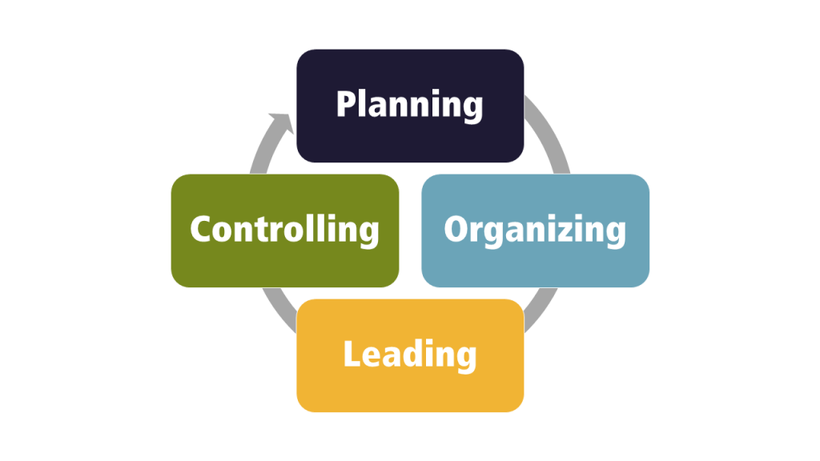
This Photo by Unknown Author is licensed under CC BY-SA-NC

3. Core Entity Identification :

- Key entities identified in the system (example):

- Users

- Items / Products / Food Donations / Medicines

- Requests / Orders / Transactions

- Notifications

- Reports

- Each entity was analyzed for its attributes, interactions, and database structure.

4. Relationship Strategy :

- Relationships between entities were mapped using ER diagrams.

- One-to-many and many-to-many relationships were defined.

- Reference keys and data linkage rules were planned.

- Data normalization was ensured to avoid redundancy.

- This step ensures accurate data flow and efficient database performance.

5. Security and Profile Planning:

- Role-Based Access Control (RBAC) strategy adopted.

- User profiles created based on job function (Admin, Staff, Volunteer, etc.).

- Authentication and authorization methods planned.

- Sensitive data protection and permission levels defined.

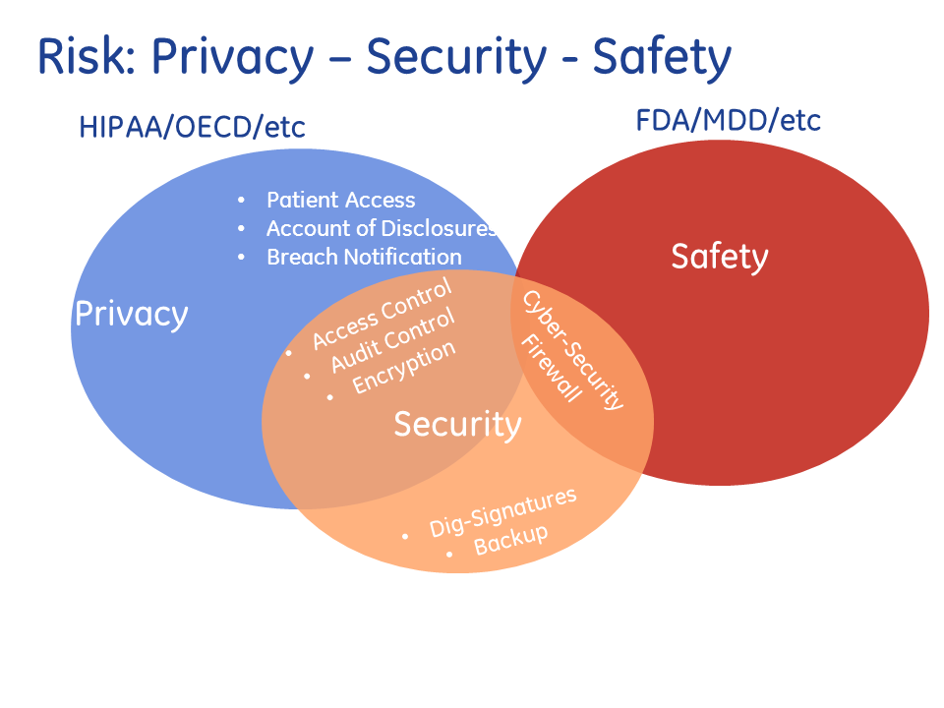

6. Data Access and Sharing Rules :

- Data access rules ensure users see only the information relevant to their role.

- Restricted edit/delete privileges to prevent unauthorized changes.

- Database views and controlled query access used for secure data retrieval.

- Sharing rules ensure smooth collaboration while maintaining privacy.

7. User Creation and Role Assignment :

- Different user accounts were defined with specific role permissions.

- Onboarding process established for adding new users in future.

- Training support planned for ensuring easy adoption of the system.

8. Environment Setup and Configuration :

- Development environment configured (software, libraries, frameworks).

- Database setup initialized with table structures.

- Test environment prepared for debugging and validation.

- Backup and version control system (e.g., Git) set up.
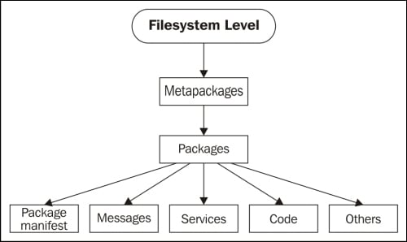
This Photo by Unknown Author is licensed under CC BY

9. Project Timeline and Resource Plan
Phase | Duration Resources Involved
Requirement Analysis  Design & Planning | 1 Week  1 Week | Team Lead + Client  Analyst + Developer
Development | 2–4 Weeks | Developer Team
Testing | 1–2 Weeks | QA Tester + Developer
Deployment & Training | 1 Week | Admin + Users

This timeline may vary depending on project size.

10. Tools and Resources Used :

- Software: VS Code / Eclipse / IntelliJ, Database (MySQL / PostgreSQL), Web Framework (e.g., React, Angular, Django).

- Collaboration: Git, Trello / Jira, Google Drive / OneDrive.

- Hardware: Standard computer systems/servers for hosting and testing.

11. Expected Outcome of the Planning Phase :

- Clear understanding of system requirements and workflow.

- Well-defined roles, security structure, and data models.

- Ready development environment with planned architecture.

- Smooth development process with reduced risks and confusion.

12. Summary :
The planning phase created a strong foundation for the project by clearly defining goals, entity relationships, access controls, timelines, and resource needs.
This ensures structured development, reduces errors, and improves coordination throughout the project lifecycle.

